Public posting on social media:

- Facebook (computer version):
  - Go to ‘Create a Post’.
  - Upload your picture by clicking ‘Photo/Video’.
  - Select your image from your computer.
  - Click ‘Open’.
  - Make sure to type #GradCapTraditions above the image in the post.
  - Click on the privacy setting box in the bottom right corner next to ‘Post’.
  - Change the privacy setting to ‘Public’.
  - Click ‘Post’.
  - Visual example:
    - 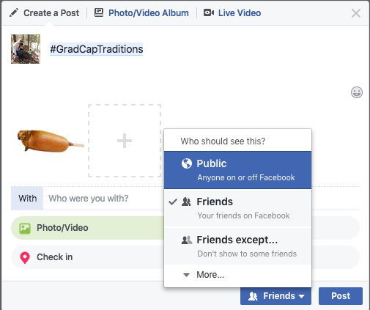

- Facebook (mobile app version):
  - Click on ‘Update Status’.
  - Upload your picture by clicking ‘Photo/Video’.
    - You may also simply click ‘Photo’ below the ‘What’s on your mind?’ box at the top of the page.
  - Select your image from your phone’s photo gallery or camera roll.
  - Click ‘Done’.
  - Make sure to type #GradCapTraditions above the image in the post.
  - Click on the privacy setting box directly below your name in the top left of the screen.
  - Change the privacy setting to ‘Public’.
  - Click ‘Post’.
  - Visual example:
    - 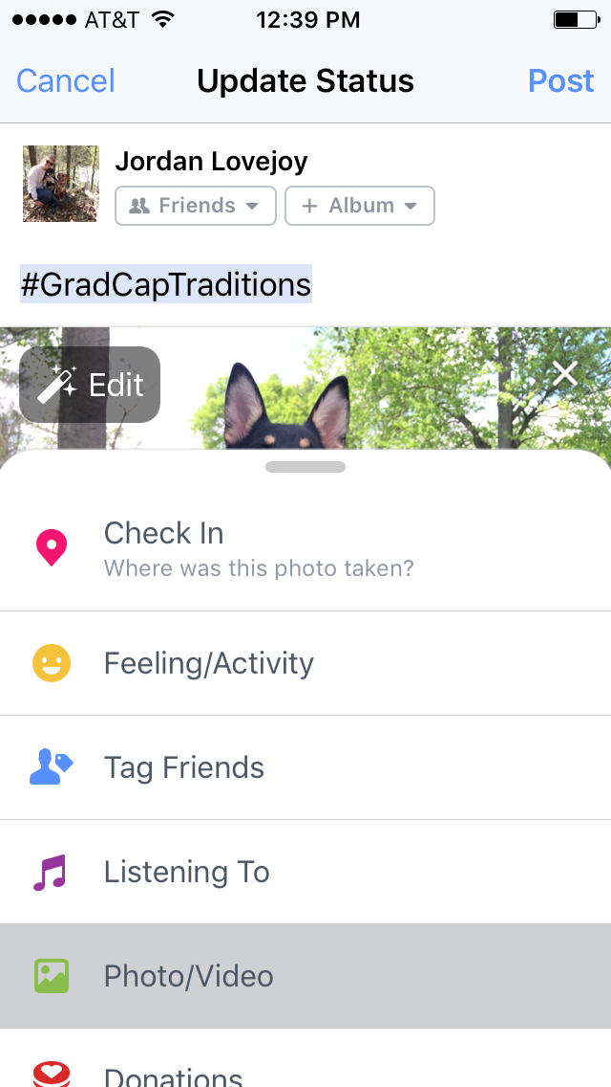

- Instagram (mobile app):
  - How to post an image of your grad cap:
    - At the bottom of the screen, you will find 5 icons. Click on the middle one, which is a square with a ‘+’ in it.
    - Select your image from your phone’s photo gallery or camera roll.
    - Click ‘Next’ in the top right corner.
    - Apply any desired filters or photo edits.
    - Click ‘Next’ in the top right corner.
    - Make sure to type #GradCapTraditions in the ‘Write a caption…’ section.
    - Click ‘Share’ in the top right corner.
    - Visual example:
      - 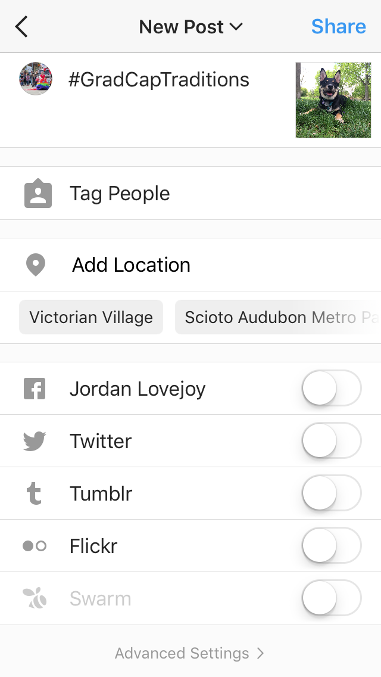
  - How to change your privacy settings (please note that Instagram does not allow individual posts to be either public or friend view only. You must make your entire account public):
    - At the bottom of the screen, you will find 5 icons. Click on the last one on the right. The icon will be a miniature version of your profile image in a circle.
    - Once you have reached your profile page, click on the icon on the top right of the screen. This icon resembles a ‘gear’ and is the ‘Options’ setting.
    - Once you are within ‘Options,’ scroll down to the ‘Account’ section.
    - Go to ‘Private Account’.
    - Choose whether to switch ‘Private Account’ to ‘On’ (highlighted in blue) or ‘Off’ (no highlight).
    - Once your entire account is public, your image will be visible through the #GradCapTraditions hashtag.
    - Visual example:
      - 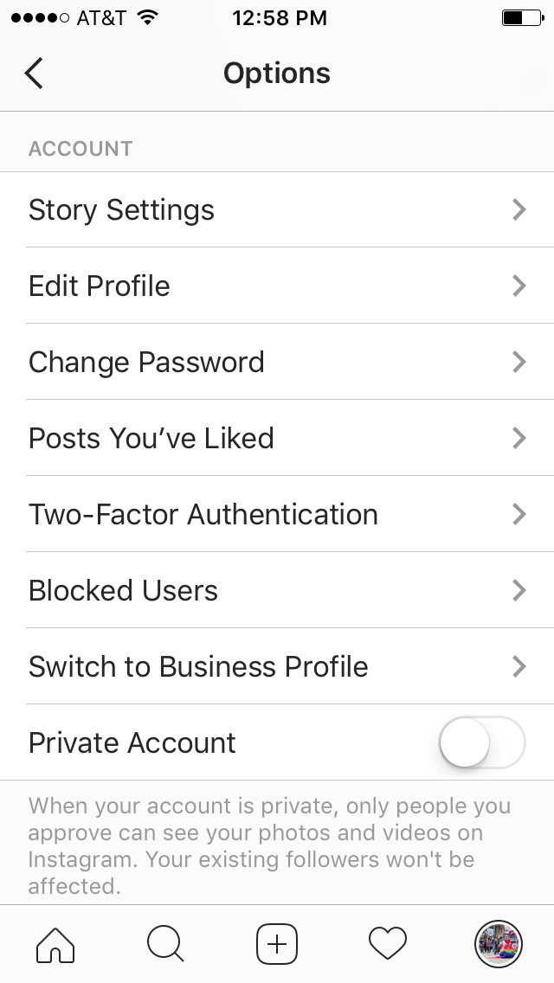
  - If you are uncomfortable changing your account to ‘Public,’ you may also visit https://cfs.osu.edu/archives/collections/gradcaptraditions for additional options on how to share your image with us.

- Twitter (computer version):
  - How to post an image of your grad cap:
    - At the top right of the screen, you will see an icon that is a blue square with a feather inside another partial square. Click on this icon to compose a new tweet.
    - Below the ‘What’s happening?’ box, you will see an icon of a camera. Click on this icon.
    - Select your image from your computer.
    - Click ‘Open.’
    - Above your photo, make sure to type #GradCapTraditions in the ‘What’s happening?’ section.
    - Click ‘Tweet’ in the bottom right corner.
    - Visual example:
      - 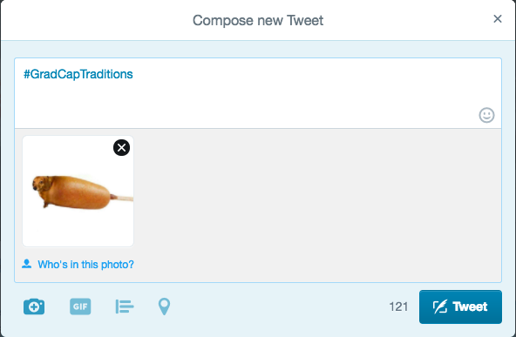
  - How to change your privacy settings (Please note that Twitter does not allow individual tweets to be either public or friend view only. You must make your entire account public):
    - At the top right of the screen, you will see three icons: a ‘Search Twitter’ option, a circle with a miniature version of your profile image, and a blue square with a feather in it. Click on the middle icon, a circle with a miniature version of your profile image, to access ‘Profile and Settings.’
    - A dropdown list will appear under this icon.
    - Choose ‘Settings and privacy.’
    - On the left side of the page, click ‘Privacy and safety.’
    - Under ‘Privacy,’ go to ‘Tweet privacy.’
    - Here, you have the option to ‘Protect my Tweets.’
    - To make your Tweets are public, simply uncheck this box.
    - Scroll to the bottom of the page, and click ‘Save changes.’
    - Visual example:
      - 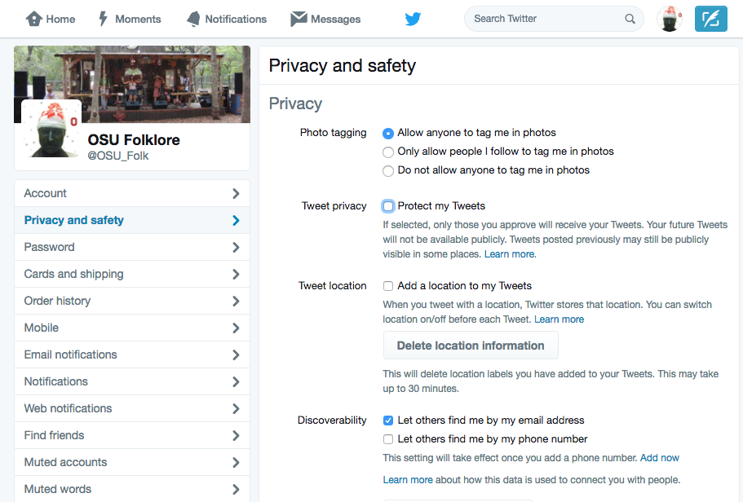
  - If you are uncomfortable changing your account to ‘Public,’ you may also visit https://cfs.osu.edu/archives/collections/gradcaptraditions for additional options on how to share your image with us.

- Twitter (mobile app version):
  - How to post an image of your grad cap:
    - At the top right of the screen, you will see an icon of a feather inside of a partial square. Click on this icon to compose a new tweet.
    - At the bottom left of your screen, you will see an icon of a camera. Click on this icon to choose your image.
    - Select your image from your phone’s photo gallery or camera roll.
    - Make sure to type #GradCapTraditions in the ‘What’s happening?’ section above your photo.
    - Click ‘Tweet’ in the bottom right corner.
    - Visual example:
      - 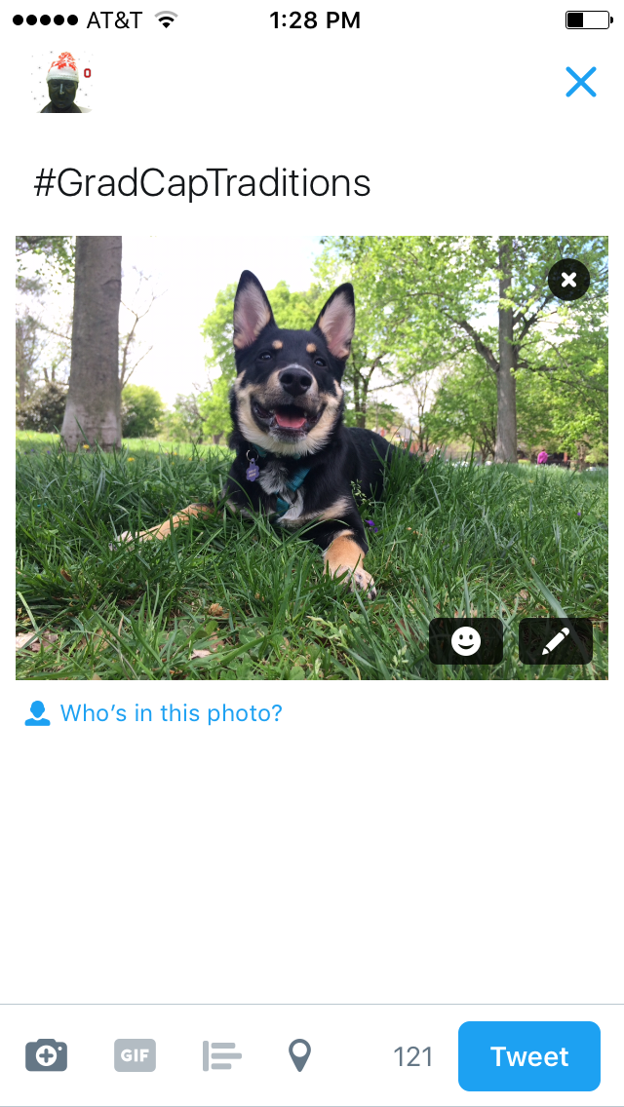
  - How to change your privacy settings (please note that Twitter does not allow individual tweets to be either public or friend view only. You must make your entire account public):
    - At the bottom of the screen, you will find 5 icons. Click on the last one on the right. The icon will be a person with ‘Me’ under it.
    - Once you have reached your profile page, click on the icon next to your profile image. This icon resembles a ‘gear’ and is the ‘Options’ setting.
    - A list of options will appear. Click on ‘Settings and privacy.’
    - Once you are within ‘Settings and privacy,’ click on the ‘Privacy and safety’ option.
    - Here, you will see an option at the top of the screen to ‘Protect my Tweets.’
    - To make your tweets public, unprotect your tweets by switching to ‘Off’ (no highlight) versus ‘On’ (green highlight).
    - Click ‘Done’ on the top right of the page.
    - Visual example:
      - 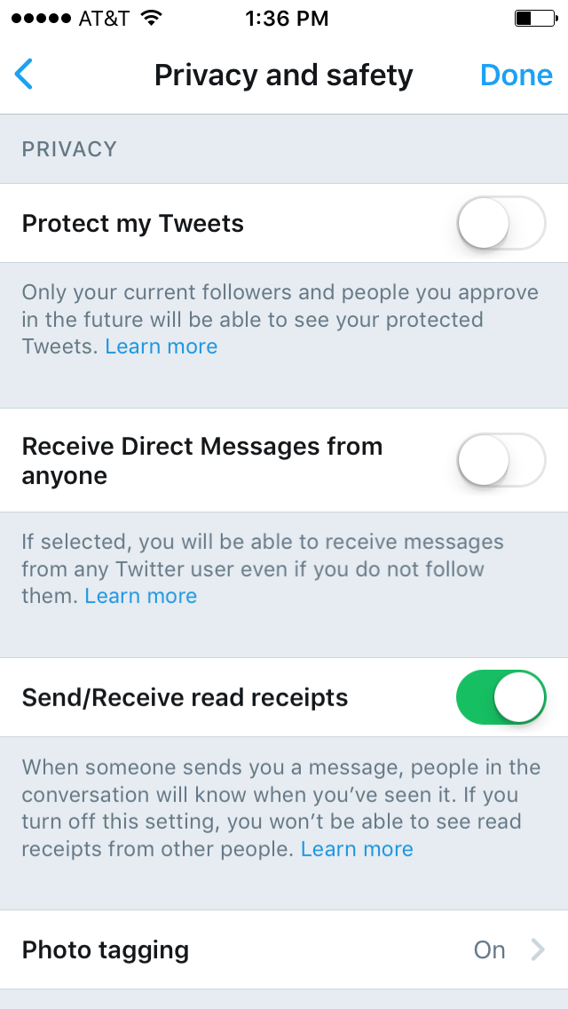
  - If you are uncomfortable changing your account to ‘Public,’ you may also visit https://cfs.osu.edu/archives/collections/gradcaptraditions for additional options on how to share your image with us.

